New Theory of Blackhole

ENGR NISHAT AMIN, ENVIRONMENT AND CLIMATE SPECIALIST

SPACE AND PLANET RESEARCHER

KNOWLEDGE DEVELOPMENT CENTRE, (KDC)

What is Black Hole

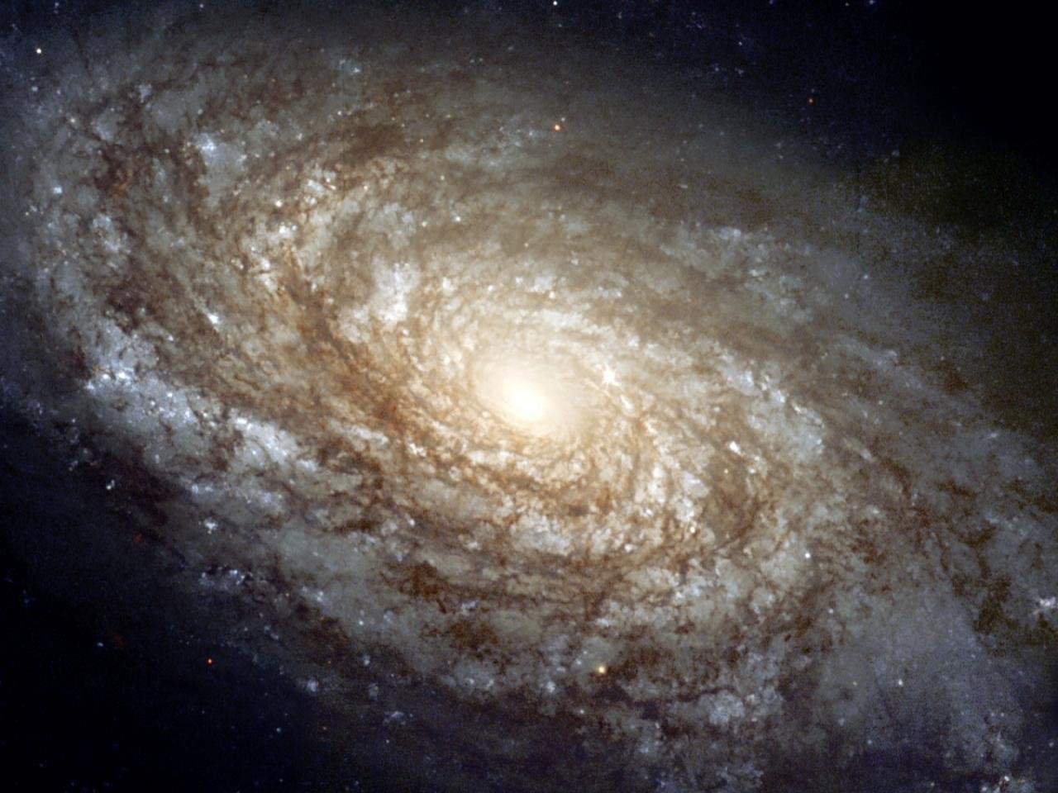 A black hole is a place in the space stayed in the heart of a galaxy where there was a alive glove once and was surrounded and modeled by its own other planet , stars, milk way , and all the set up of a galaxy.

Photo: A Live galaxy of its own setup

Image : A black hole with its galaxy surrounded with:

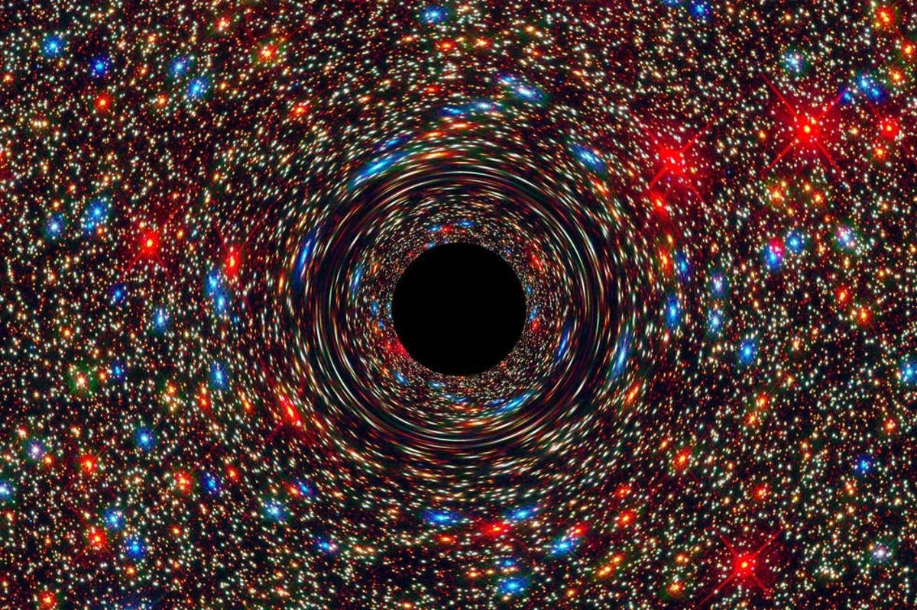

So its like a black hole is a empty planet or a planet which already lost its all energy and light under its gravity and become a open mouth to eat anything passes by it. Its like a painful heart which is goes through trauma and lost its power and energy and dies and now ready to revenge by eating anything its comes to its way.

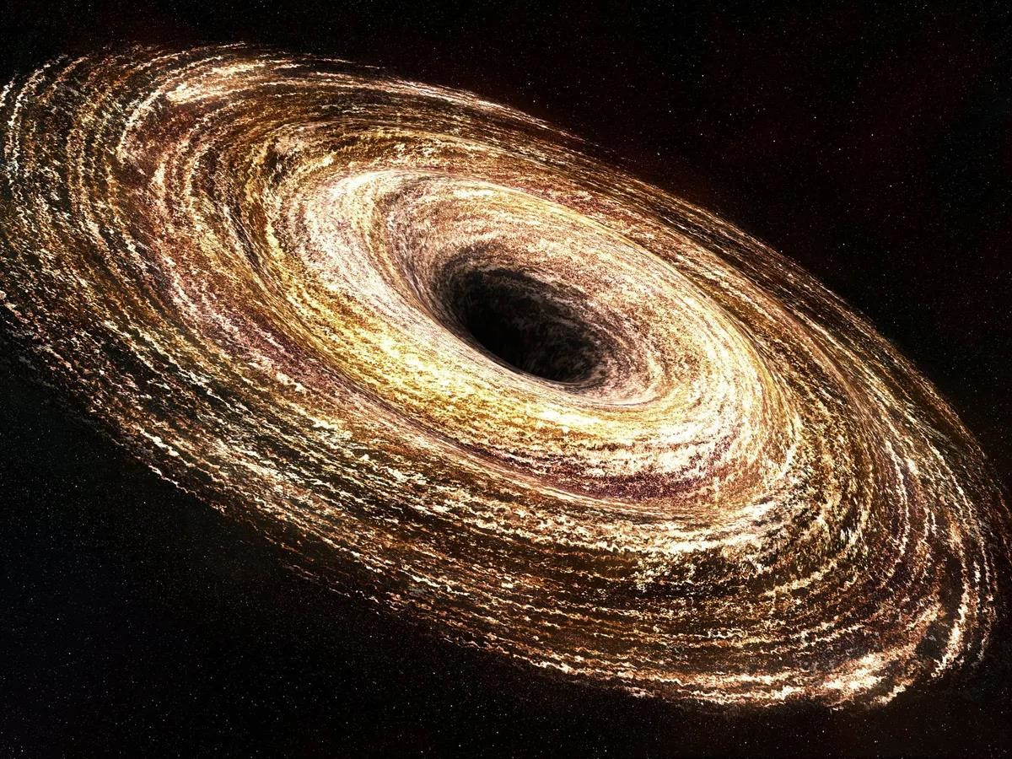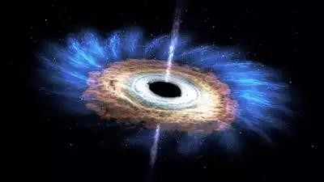

You can also define some black hole like that it has replaced from its own place of galaxy or stolen by and the empty place waiting for its place to recover by attracting and consuming anything its comes to its way

An image of a stolen or replace planet which become a black hole

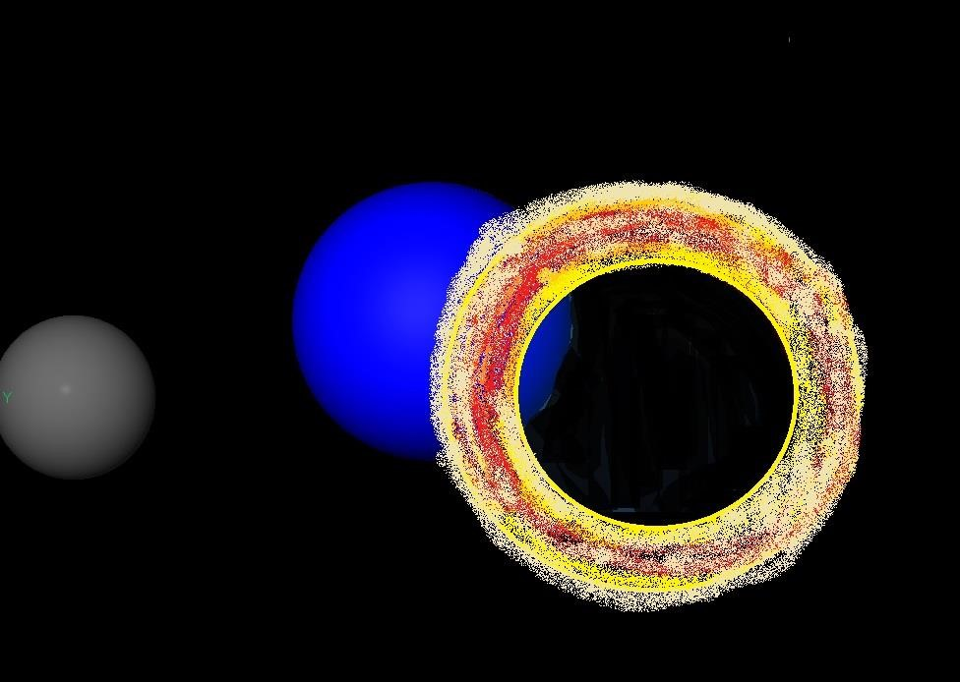

Sometimes a black hole is just a gate way of light in the universe to the opposite and there is only certain category of light that can passes by the black that type of transparent or peace hole where there is no pulling to suck inside but a way to enter two side. But scientist can discover more about this in Future. Image : Empty peaceful black hole entrance for light covered by its own galaxy shoulder.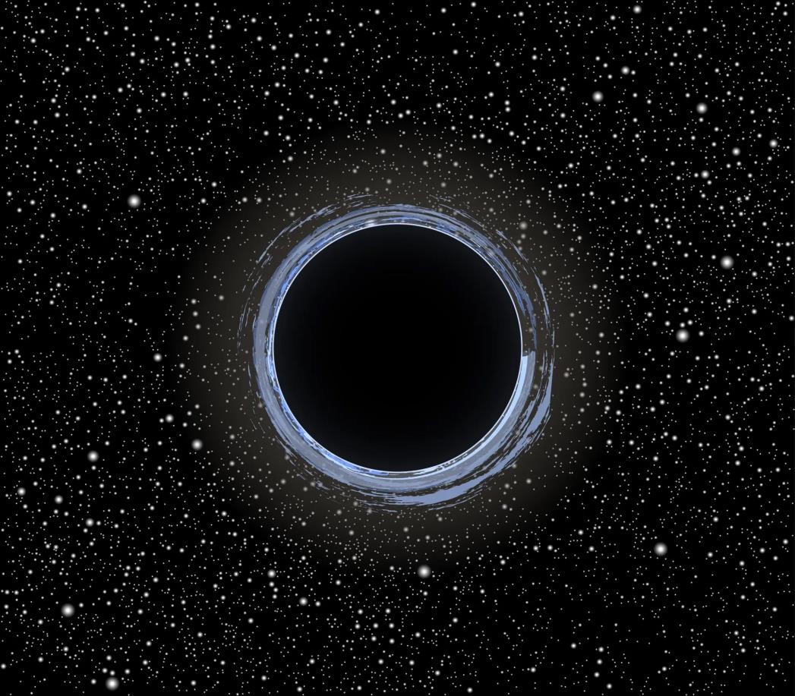

The black hole is like such a state of space where you can find a giant monster mouth or a painful hole which lost its energy and can eat any of the planet passes by or a joyful entry of light with holding all peace other side surrounded by its shoulder galaxy.

Thanking you Nishat Amin Moni

SEE YOU ON NEXT INVENTION.

STAY WITH THE SCIENCE AND CREATION